THE ASHLAND YMCA
“Y” Kids
HANDBOOK

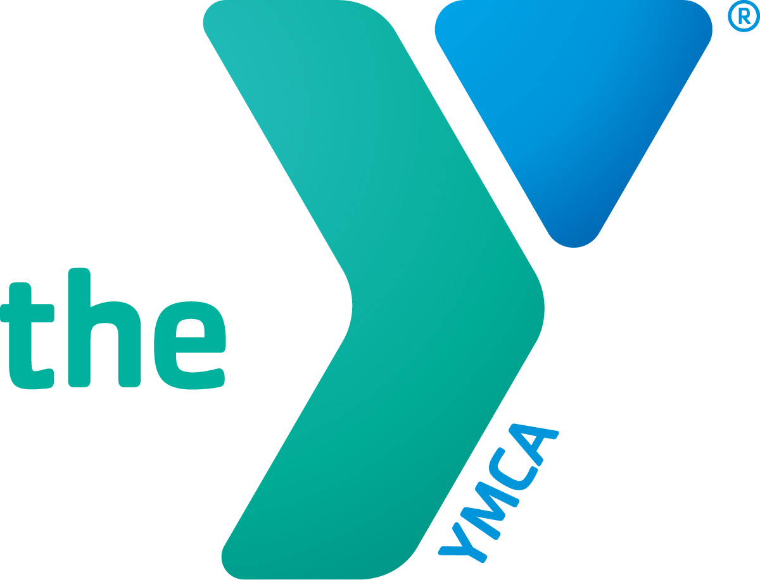
ASHLAND YMCA
207 MILLER STREET
ASHLAND, OHIO
419-289-0626
www.ashlandy.org
Handbook updated 1/2023

Welcome!
The Ashland Family YMCA welcomes you to our center! This handbook contains information regarding our program. It is very important that you read this handbook and keep it handy as long as your child is enrolled in the program. It will answer many of the questions you have about the Ashland Family YMCA “Y” Kids. We are confident that your child will benefit positively from our unique program. Please feel free to contact the Director for any further information.

Licensing
The YMCA “Y” Kids is legally licensed to operate by the Ohio Department of Job and Family Services. We are licensed for Kindergarten to fifth grade. We are inspected annually and you are welcome to ask questions about this at any time. We are currently a three star program in the Step Up to Quality program.

Philosophy and Goals
The Ashland Family YMCA “Y” Kids Program is designed to encourage the development of the whole child. We shall provide experiences that nurture a positive self image, socialization, creative thinking and a love for life and learning. To achieve these goals, the staff and parents need to work together as partners. We are pleased that you have chosen to include us in the growth and development of your children. We are open to all children regardless of race, sex, color, ability, religion or national origin.

Curriculum
We will be following Cincy After School Curriculum in the “Y” Kids Program. The organization of the classroom is crucial to the success of our program. Materials and equipment have been chosen to challenge and interest the child. To meet the child’s developmental needs, some curriculum activities include: art, language arts, science, gross motor, fine motor, dramatic play, math, music, geography, manipulatives, socialization skills, cooking, blocks, swimming, and gymnastics. The children will be assessed when necessary and communication will happen between parent and administrator. A conference will be set up if necessary between parent, administrator and staff involved with the child.

Admissions
A child is considered to be enrolled in the center only after there has been a meeting or an email with the administrator, all paperwork has been completed and approved and the registration fee has been paid. A welcome email will be sent with additional information that will make your transition and daily routines easier. Any change to your personal information should be communicated to the administrator immediately so that current information is always on file.

Hours and Days of Operation
The center is open 6:30am-6pm with care before school until the city school bus picks up and care after school after the bus drops off at the end of the school day. There is care on no school days and holiday breaks by sign up only and there is an additional charge for that care. There is also one week in August that the YMCA itself is shut down to do major repairs and cleaning projects. It is typically the third or fourth week of August and is signified by the end date for Summer Camp. Once the week of Shut Down ends we will open the center for care to begin. The center as a whole will also close for major holidays, such as, but not limited to 4th of July, Labor Day, Thanksgiving, Friday after Thanksgiving, Christmas Eve and Christmas Day, New Years Eve and New Years Day, Good Friday, and Memorial Day.

Staff/Child Ratio and Group Size
The Ashland YMCA “Y” Kids is licensed to operate with a maximum of 22 children per classroom each session, not to exceed the following state ratios:
1:14 4-5 year olds 1:12 3 year olds 1:18 School Age children
Limitations do not include outdoor time or special activities.

Daily Schedules
Morning and Afternoon
6:30-8:30 Morning care/breakfast until bus arrives
3:30-6 Afternoon care/snack, activities until parent pick up
Fun Club Days
6:30-8:30 Breakfast with open activities in the classroom
8:30-11 Crafts and intentional activities
11-12 Lunch and prepare for swimming
12-1 Quiet time with books, puzzles and etc.
1-3 Crafts and intentional activities
3-6 Open play in banquet room, gym or playground

These time frames are flexible and vary with swimming, or special events.

Birthdays
Birthdays may be celebrated with a nutritious snack. The children will sing and do other things to make this a special day for your child. Please limit sweets. Please be cautious when you send cupcakes. The children do not eat them, and it makes a monster mess! A good alternative is cookies or a prepackaged treats.

Toys/Jewelry/Money from home
Please do not send toys, jewelry or money to school with your children. They often give them to a friend or lose them which creates unneeded stress for the children and staff.

Transportation of Children
The Ashland Family YMCA “Y” Kids will not transport children in emergency situations. If a child requires transportation, the parent or the emergency squad will be contacted. We do not transport children for field trips or to/from other locations, the city school bus will pick up in the mornings and drop off in the afternoons, but must be set up by the parent. All other transportation of children is left to the responsibility of the parent(s).

Accidents/Emergencies
Should we need to evacuate due to fire, weather conditions, the loss of power, heat, or water to the center our emergency destination is CVS on Main Street. A sign would be posted on the entrance door indicating that we have evacuated and the location you can pick up your child. Parents will be contacted as soon as possible to come and get your child.
All staff members are trained in First Aid and CPR. Most of the staff also have training in Communicable Diseases and Child Abuse. In the event of a minor injury/accident staff will administer first aid and care. If the injury is more serious, first aid would be administered and parents would be contacted immediately. If any illness/injury is life threatening, the EMS will be contacted, parents notified, and a staff member will accompany the child to the hospital with all available health records. An incident/injury report will be completed and signature of parent or guardian of the child within 24 hours. If you would like a copy of the report, ask when it is being signed and a staff member will copy it for you to take home. A copy of the report must remain at the center in the child’s file.

Swimming
We will offer swimming times for the children to gain those experiences on Fun Club Days, when school is not is session throughout the school year. If your child is here on those days they will need a suit and towel each day. A permission slip must be signed by the parent or guardian. Certified lifeguards will be on duty for all swimming lessons and two staff will be present at all times.
Outdoor Play
Research has shown that children stay healthier when they have daily outdoor play. Based on this information and state requirements, outdoor play will be included in our day when weather permits. On the days that outdoor play is not an option, we will have time for indoor gross motor activities. Be sure to dress your child accordingly. Our policy is NO FLIP FLOPS please!

Parent Participation Policy
Procedures, policies and curriculum can be discussed with the administrator at any time. There will be a Harvest Dinner in November that will offer the opportunity to the parent(s) to discuss subjects with the administrator and/or staff members. Monthly newsletters will be distributed to the parents via email concerning the curriculum, schedules and coming events. Parents are encouraged and welcome to participate whenever possible in activities. Teachers and the administrator are available to discuss your child’s progress or needs at any time. For lengthy conversations, please make an appointment so that the teacher can focus on you and your child during these times. If you have any questions it is recommended you speak to your child’s teacher, the administrator, and finally the CEO of the YMCA, in that order. Bring up your concerns ASAP so they can be addressed and not turn into bigger problems. An open line of communication is necessary for a good school year and experience.
We have a school roster that you may/may not give permission to be on or to limit information shared. This option will be offered during registration.

Guidance Policy
We believe that helping the child to learn self-control is very important. Our hope is each child will learn self-discipline through careful guidance. Your child will be treated with love and respect. If children are treated with respect, they in turn learn to respect others. Our expectations will be kept within the child’s capabilities and the child will be made aware of these expectations. Positive reinforcement and redirection will be used. A child may be given a short period of time apart to give them a chance to regain control if they are having a difficult time. Time outs will be age appropriate in length and done within the classroom. If a situation arises where a child is consistently endangering themselves or others, it may become necessary to dismiss the child. EVERY attempt will be made to work with the parents and child to correct the behavior. We may need to implement a behavior management plan for children that require “extra attention” from the staff.

Supervision Policy
The responsibility of our staff is to ensure the health and safety of each child entrusted in our care. We will be alert to the safety needs of our children, anticipated possible hazards and take necessary precautionary and preventative measures, including but not limited to:

1. No child will be left alone or unsupervised.
2. No child will be released to any person not authorized to pick up the child. Written authorization must be given to the center in this regard.
3. Parents must keep the child inside the car until a staff person comes for them. Staff will return children to the car at dismissal time.
4. Staff will escort the children from the car to the classroom and back.
5. There will be immediate access to a working telephone at all times.
6. Fire drills will be held monthly. A record will be available upon request. An emergency alert plan can be implemented by the staff. The plan is posted in all rooms.
7. Tornado drills will also be held seasonally.
8. The use of aerosols is prohibited when children are present.
9. The staff is mandated by LAW to notify the local children's protection agency when they suspect abuse or neglect.
10. Parents will be contacted immediately when children become ill and need to be picked up.
11. Staff will not release children to anyone, including parents, who appear to be drunk or under the influence of drugs. Emergency contacts will be called to transport children home.
12. Custody agreements must be provided to the center with court papers indicating who has permission to pick up the child. The school may not deny a parent access to their child without proper documentation.

Pick up and Drop Off Times:
If you are running late to pick up your child PLEASE call or email ASAP. Children get very upset when all their friends are gone, and their ride is not there. We understand things happen. If we are aware, we can find things for your child to do to keep them busy. Habitual tardiness to pick up your child will result in a $1.00 per minute fee.
Anyone who is to pick up your child, other than the parents, must be listed on the pick up list that is completed at registration and must be at least 16 years of age.

Delay and Closing Policy
We will be following the Ashland City Schools Schedule for delays and snow days. In the event that school is delayed or canceled for weather, Fun Club Days will be available at an additional charge. The newsletter and website will be updated to reflect any other schedule changes.

The purpose of the Fun Club Days is for working parents who need all day care for their child. During planned closings such as Thanksgiving, Christmas and Spring Break, we will have a “need based” sign up for Fun Club Days. If we do not have the required 6 children per day for the break, we will not be open. We will make sure to inform all parents in plenty of time to find other care if we are not going to be open. We understand this will cause some families to be inconvenienced, but it is not in the best interest of the YMCA to be open for less than 6 children. Please address any questions to Christie Krumlaw before registering if this is an issue.

If you have any questions, please feel free to call me at 419-289-0626 at the YMCA or email me at ckrumlaw@ashlandy.org.

Tuition/Fees and Payment Policies
A fee schedule is available upon request and is included on the enrollment sheet. Monthly payments are due at the beginning of each month. Checks are to be made to the Ashland YMCA and can be paid by dropping payment in the drop box by administrator office door or given to a staff person. You can also go online into your portal and make payments at any time. There is also an option to schedule payments, those payments will be taken on the first of every month unless otherwise stated on the payment form. Late payments that are made after the 10th of every month will be charged an additional $20 fee. Returned payments for insufficient funds will incur an additional fee of $30 per check. Registration fees are non-refundable. A yearly rate has been determined and then divided into nine monthly payments, so holidays have been taken into account. Our tax ID number is available upon request. The “Y” Kids program reserves the right to exclude the child from the cneter if tuition is more than 2 weeks late. The “Y” Kids program requires a two week written notice to withdraw your child from the program You will be responsible for the amount due monthly until written notice is given. Once you are enrolled with our program it is a commitment of a minimum of 3 months attendance. You will be responsible for payment for a minimum of three months and a two week notice is required to withdraw your child. Please speak directly with administrator if you have any questions or concerns. Excessive (3 or more) late payments could result in payments being automatically deducted from a personal account. If a balance remains for more than 1 month your child will be removed from the program and will not be able to return until it is paid in full. Once that happens more than once it is possible and very likely that you will be permanently removed from the program. There is a 10% discount off the second child enrolled in the program. Payments are expected in full regardless of attendance of the child. These payments are spread out per month but are based on the amount of total days attended throughout the school year. If you have a special need of a payment plan please contact Christie Krumlaw at 419-289-0626.

Partner with Youth Program
For families that are struggling with tuition and YMCA memberships, we have a program called Partners with Youth. This program allows the YMCA to keep its promise of no one being turned away due to inability to pay. An application can be picked up at the front desk, or can be obtain for you. The process is simple and private. Contact the administrator or the front desk for further information.

Snacks
Children have snack on a daily basis and we focus on healthy foods. If we have any children with food allergies we are very cautious and take it seriously. The center will provide the snacks. We are a nut free center, if we are fortunate enough to have no allergies we may use nut products. Please be clear about allergies on the Child Medical/Physical Care Plan.

Management of Illness
The Ashland YMCA “Y” Kids provides children with a clean and healthy environment. We realize that children become ill from time to time. If this is your child’s first year in care, it is possible that they may experience more frequent illnesses at the beginning before their immune system becomes more active. We observe all children as they enter the program to quickly assess their general health. Please DO NOT bring a sick child to care. They will be sent home immediately. Parents will be notified if the children have been exposed to a communicable illness. A doctor’s note will be required after a communicable illness for admission back to care. If they have had a fever in the past 24 hours they are not permitted to be at care. They must be fever free with no medication for a minimum of 24 hours before returning.

Medications: “Y” Kids will only administer medications to a child after a “Request for Medication” form has been completed by a doctor with written instructions. Emergency inhalers, Epi-pens, seizure medications will be kept in the storage office in the first room for easy access by all teachers.

ODJFS Families
Please make entries of in and out times daily. The tablet will either say accepted or denied. If it is denied, please tell the administrator or a staff member immediately so it can be fixed. Co-pays are due at the beginning of every month unless arrangements are made with the administration in advance. You will not be permitted to begin our program until your application has been processed with ODJFS. We will hold the spot that you would need for 30 days to be processed after that time your spot will be opened back up. Falling behind in entries can cause a family to become self-pay and will incur a $10 fee per week that the entries were missed. It is important that you log in daily and keep it up to date to be sure ODJFS gets the correct information to avoid the self-pay option. If there is an absence of longer than 2 weeks from the program, you will become self-pay and will need to pay for the two week absence as well as any balance accrued from there. All entries must be completed and up to date by every Friday at 6:00pm. The entries need to be submitted on Monday morning, if they are not complete there will be a $10 charge added to your account and will need to be paid by the end of the next week. There is an app you can download on your phone to do your entries from your car and to approve any changes that need to be made to your child's attendance. This app is KinderSmart. It will walk you through the process to be able to utilize that option. There is a QR code next to the tablet in the lobby that will help you use the app.

Fun Club Days Participants
-Please bring a lunch daily with an ice pack to keep food cold. Feel free to bring a gallon/half gallon of milk for your child so you don’t have the inconvenience of packing it daily.
-Due to the large numbers of children, please try to limit how much warming up is needed per day.
-Lunches MUST follow the state guideline so we are not in violation and receive a non-compliance from the state. See attached state guidelines. Questions? Contact the administrator. Please do not send nut items in their lunch, due to so many allergies in the center.
-Bring a suit and towel daily, children will most likely swim daily.

If you are a full-time working family, we will have care provided during breaks from school. For these times we will do a sign up separate from the regular schedule. You will need to do the sign up to be allowed to be here for those days. If you do not sign up in advance, there will be an additional charge added to your bill of $15 a day attended. It is necessary that we know who will be here to be sure we staff it sufficiently. You will also only be allowed to attend the hours that you sign up for and will be charged $1 a minute over the time that is signed up for. Once again, this is to be sure we are staffed correctly to accommodate the number of children in our care. A note will be sent home a minimum of 2 weeks ahead of time. If you do not receive this note it is your responsibility to ask for one.

In-service Policy
Due to changing regulations to the licensing for preschool/child care centers we reserve the right to close the school/center up to once a month to attend in-service trainings to keep our license valid to serve you with quality care. For when this occurs please have a backup plan in place for the care of your child(ren) for that day.

If you have any questions or concerns throughout the program, please feel free to stop in and discuss them. We may amend this handbook to reflect policy changes mandated from the State of Ohio or the YMCA. Families will be informed of these policy changes.
Christie Krumlaw
Christie Krumlaw
Child Development Director
419-289-0626
ckrumlaw@ashlandy.org

